Declaration of conformity

Type of equipment: CO₂ Sensor in a housing
Brand name or trademark: Senseair S9
Type designation(s)/Model No(s): 099-16-00xx

Name: Senseair AB
Address: Box 96, SE-824 08 Delsbo, Sweden
Tel: +46 653 717770

This declaration of conformity is issued under the sole responsibility of the manufacturer.
The equipment of the declaration described above is in conformity with the relevant Union harmonisation legislation according to the:

EMC Directive 2014/30/EC
The above stated equipment has been tested according to relevant parts of the “Electrical equipment for measurement, control and laboratory use” standard EN IEC 61326-1:2021,
and has been found to comply with the required performance criteria stated therein.

Group 1 Class B emission requirements according to EN IEC 61326-1:2021
Industrial immunity requirements according to EN IEC 61326-1:2021

RoHS Directive 2015/863/EU
As manufacturer we declare, under our sole responsibility, that the equipment follows the provisions of the Directive stated above. It does not contain the following hazardous substances above the thresholds indicated in the directive, except in applications exempted from the restrictions, exemptions 7(a), lead in high temperature solder and 7(c)-I, lead in glass or ceramics:

-Lead (Pb) -Polybrominated Diphenyl Ethers (PBDE)
-Mercury (Hg) -Bis(2-Ethylhexyl) phthalate (DEHP)
-Cadmium (Cd) -Benzyl butyl phthalate (BBP)
-Hexavalent Chromium (CrVI) -Dibutyl phthalate (DBP)
-Polybrominated Biphenyls (PBB) -Diisobutyl phthalate (DIBP)

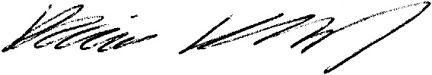

____________________________________ 2025-11-20
Daniel Karlsson Date
Compliance Engineer

